写作比赛样题
Part I (40 points)
Directions: You are Justin Jia. You saw a job ad for an after-sales clerk on China Daily. You decide to apply for the job by email (of at least 200 words) to John Smith of WY E-commerce, the hiring manager. You should not include any real information about yourself in your writing. Your email should contain a salutation, a main body and a close. The body of your email should include the following points:
introduce yourself and express your interest in the position;
provide your qualifications and skills for the position;
thank the hiring manager and ask for an interview.
Part II (60 points)
Directions: The charts below show the proportion of global electricity generated from different sources in 2022 and the proportion of global electricity expected to be generated from different sources in 2050. Write a report (of at least 300 words) to describe the charts, analyze the data, and make some comments/suggestions/predictions.
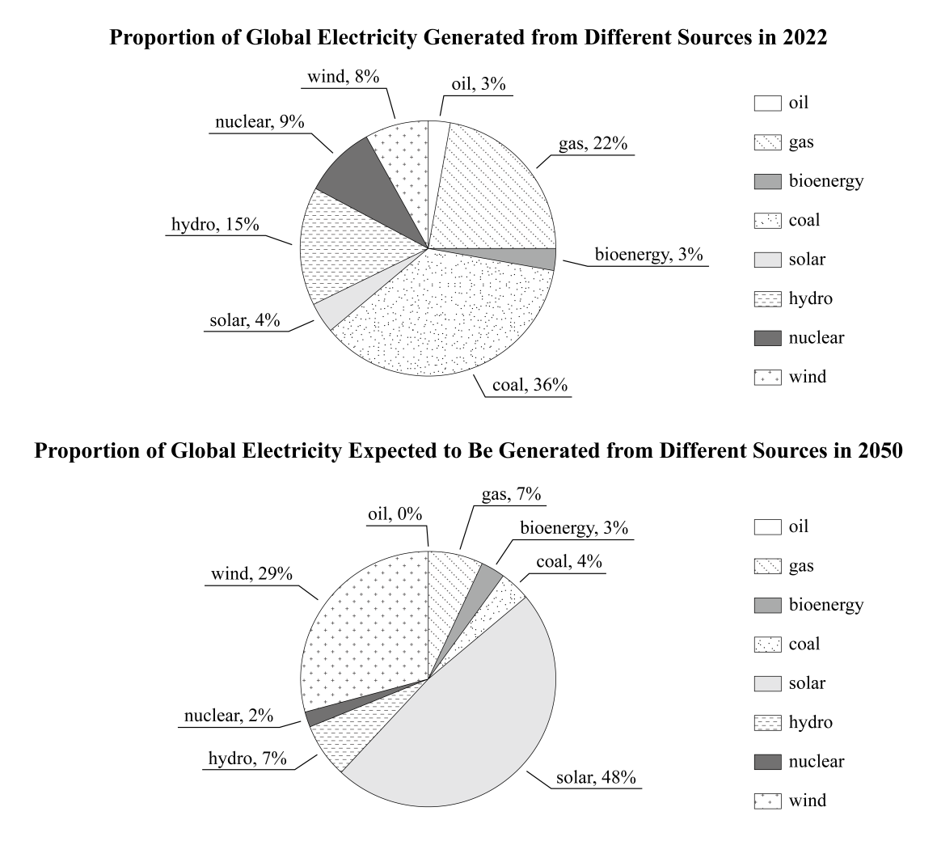
为保证竞赛公平性、写作比赛题目当场公布。以上为省赛样题，仅供参考。

